**Client Report**

**Client Name:** Siva Prasad

**Organization:** TCS AXA Belgium

**Prepared By:** Abhriam Majeti-2320030108

Sachita S Limaye-2320030134

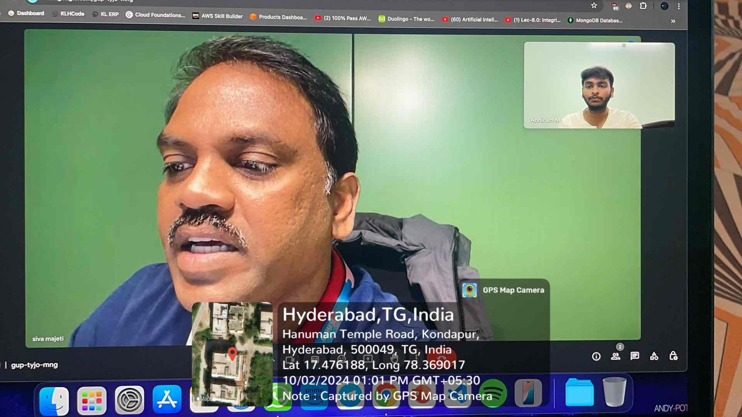

**Objective:**

The primary objective of this project is to enhance campus security by developing an AI-based system that automates the identification and real-time location tracking of individuals within the college premises. This system will use advanced technologies such as Optical Character Recognition (OCR) to extract data from ID cards and facial recognition to match individuals with live surveillance camera feeds. By seamlessly integrating with the campus's existing security infrastructure, the project aims to streamline the process of finding and locating individuals in real-time, ensuring both efficiency and compliance with privacy and security regulations.

**Questions Discussed**:

1.What is the primary purpose of implementing this system?

**- Answer:** The system is designed to enhance campus security by providing real-time identification and location tracking of individuals, streamlining the process of finding people using college surveillance cameras.

2. What datasets are available for training the facial recognition and ID scanning models?

**- Answer:** The project will use an ID Card Dataset, a Facial Recognition Dataset, live Surveillance Camera Feeds, and Location Mapping Data. Privacy and security compliance datasets will also be utilized to ensure lawful data handling.

3. How many surveillance cameras are installed across the campus, and how are they distributed?

**- Answer:** The exact number and distribution depend on the campus layout. However, for optimal tracking, we recommend ensuring that all main entry/exit points, corridors, and open spaces are covered.

4.What type of ID cards do students and staff use, and what data is available on them?

**- Answer:** The ID cards contain textual information like unique ID numbers and names. Optical Character Recognition (OCR) will be used to extract this data for person identification.

5. What facial recognition accuracy is expected, and how will false positives or negatives be handled?

**- Answer:** We aim for a high confidence score, typically over 90%, using pre-trained neural networks for facial recognition. False positives/negatives will trigger alerts for manual verification, ensuring minimal impact on real-time monitoring.

6.What security measures will be in place to protect the privacy of individuals and restrict data access?

**- Answer:** Data will be encrypted, and access will be restricted to authorized personnel. Compliance with privacy laws will be ensured through periodic audits and secure handling of personal data.

7.What is the expected response time for the system to identify and locate an individual?

**- Answer:** The system will provide near real-time results, depending on network bandwidth and camera processing speed. Typically, it should take a few seconds to identify and locate an individual after scanning the ID.

8.How will the system handle situations where a person is not visible on any camera feed?

**- Answer:** If no match is found, the system will continue scanning feeds until the individual appears. In case of prolonged failure, a notification will be sent for manual search intervention.

9.What integration is required with the existing campus security infrastructure?

**- Answer:** Integration with existing camera networks, APIs, and security systems is essential. The system will need to interface with these systems to access real-time video feeds and provide location-based tracking.

10.What type of user interface or dashboard do you envision for the security team?

**- Answer:** The system will feature an intuitive dashboard showing live camera feeds, real-time location updates, and alerts. Users can search for individuals by scanning IDs and monitoring locations visually.